**A. Notes on Data Extraction as It Appears in Current Data Library**

1. The main paper in this folder is Craft (2007). "Freshwater input structures soil properties, vertical accretion, and nutrient accumulation of Georgia and U.S. tidal marshes". Limnol. Oceanogr. 52: 1220–1230.

2. The sites in this study were coded in the data library as follows:

|  |  |  |
| --- | --- | --- |
| **Library** | **Paper** | **Notes** |
| site1 | Site1 Eulonia (Sapelo River), Levee |  |
| site2 | Site2 Four-mile (Sapelo River), Levee |  |
| site3 | Site3 N Sapelo (Sapelo River), Levee |  |
| site4 | Site4 Meridian (Doboy Sound), Levee |  |
| site5 | Site5 Folly River (Doboy Sound), Levee |  |
| site6 | Site6 Dean Creek (Doboy Sound), Levee |  |
| site7 | Site7 Carr’s Island (Altamaha River), Levee |  |
| site8 | Site8 Alligator Creek (Altamaha River), Levee |  |
| site9 | Site9 Rockdedundy Island (Altamaha River), Levee |  |
| site10 | Site1 Eulonia (Sapelo River), Plain |  |
| site11 | Site2 Four-mile (Sapelo River), Plain |  |
| site12 | Site3 N Sapelo (Sapelo River), Plain |  |
| site13 | Site4 Meridian (Doboy Sound), Plain |  |
| site14 | Site5 Folly River (Doboy Sound), Plain |  |
| site15 | Site6 Dean Creek (Doboy Sound), Plain |  |
| site16 | Site7 Carr’s Island (Altamaha River), Plain |  |
| site17 | Site8 Alligator Creek (Altamaha River), Plain |  |
| site18 | Site9 Rockdedundy Island (Altamaha River), Plain |  |

**B. History of Calculation Refinements**

1. Soil C pool data was calculated by SAS, data was from Table 3.

Soil C pool (OCg_cc)= Bulk density (g cm-3) * Organic C (%)

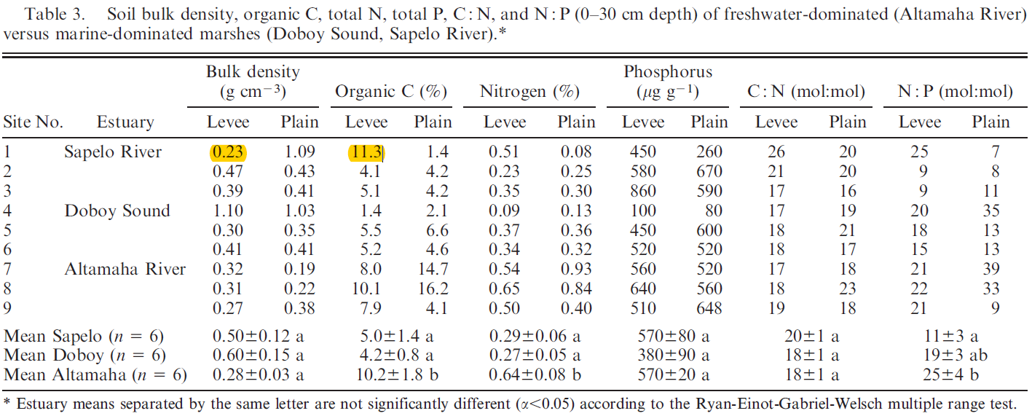

2. Soil C rate data: Meng was not able to find the Soil C rate data. (Data was from tab ‘salt marsh rate’, row 110, 111, 112, and tab ‘tidal freshwater soil’, row 25)

***[Response]*** *I don't know how the numbers in these rows were calculated.... I have tried different options with the data in the paper and I cannot get the same numbers.*

*I recommend updating them with new values. the easiest way for you to calculate C rate from the data in the paper is to look at figure 5, because this figure already has data averaged by salinity (see numbers over the bars). take the sedimentation (kg m-2y-1) and multiply it by the %C and adjust units to get gC m-2y-1. Example: in freshawter tidal, 1.15kg/m2/y = 1150 g/m2/y; 1150*(17/100) = 195.5 gC/m2/y.*

*remember not to include freshwater tidal marshes in this salt marsh dataset, they should be compiled with the freshwater tidal numbers in the other tab. brakish data is ok to copile with saltwater data.*

Meng confirmed that the Soil C Rate data was from Fig. 3a according to Blanca’s response.

